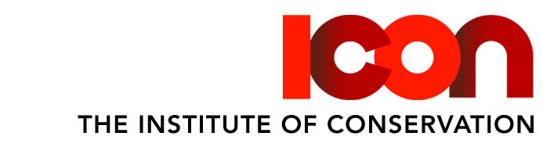

Icon Advertising – Booking Form

Contact Details
Name
Contact Email/ Tel no
Company
Contact Address

Registered Number
Charity Number
Finance Contact Details

Advert Details
Company/ Organisation
Job title
Date to be advertised
Order No

For Office Use
Amount due
Advert/ Proof received |  | Date

Terms & Conditions

Payment terms are strictly 30 days from date of the invoice; all prices quoted are exclusive of VAT unless otherwise stated. A booking is only confirmed when a signed form has been received, forms can be emailed to paul@centuryone.uk. If you have any queries, please contact Paul Heitzman (paul@centuryone.uk).

Signature
Name (printed)
Date

