

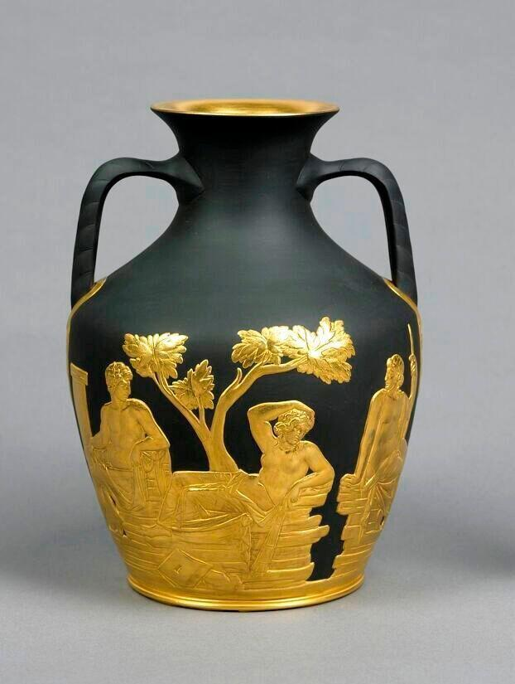

NIGEL WILLIAMS PRIZE

INFORMATION PACK

This information pack is aimed at assisting potential applicants for the

Nigel Williams Prize.

Last updated September 2024

Part 1: Application Process

Part 2: Eligibility

Part 3: Assessment Criteria

Part 4: Project Report Outline

# Part 1: Application Process

The Nigel Williams Prize is for an outstanding professional or academic project focusing on the interventive conservation of ceramic or a directly related material. Submissions are welcome from individuals or teams from the private, the public or the educational sector.

Applicants must be members of a professional membership. Submissions from **students** who do not hold membership to a professional organization will be considered for the Student Award.

The project must have been completed within the three year period prior to the Award deadline.

Applicants will only be considered if they:

1. Fill in the **Application Form –** found on the website of The Institute of Conservation [Nigel Williams Prize (icon.org.uk)](https://www.icon.org.uk/groups-and-networks/ceramics-glass/nigel-williams-prize.html), and
2. Submit the following documentation to [icon.nwp@gmail.com](mailto:icon.nwp@gmail.com)
   1. **Brief CV**(s) of applicant(s) – this should focus on professional activities and qualifications and should **NOT** exceed one single-spaced A4 page.
   2. Project Report – see Part 4 of thisinformation pack for a template.

# Part 2: Eligibility

Submissions are welcome from individuals or teams from the private, the public or the educational sector. Teams should be led by a Conservator and the majority of the work illustrated should focus on Conservation processes rather than, for example, procurement of replacement parts. Teams based in Museums and Private Practice, collaborations between freelance conservators and Heritage Sector personnel are all welcomed.

The project presented will be concerning the conservation of one or more of the following materials:

* Ceramic
* Glass
* Enamel
* Plaster
* Small portable stone objects

N.B Please do get in touch with the Prize Coordinator if you would like to discuss if your project qualifies.

# Part 3: Assessment Criteria

Please make sure you select which Award (Main Prize or Student Prize) you are applying for on the Application Form. Eligible projects will be assessed according to the criteria listed below.

Submission for the **Main Prize** should demonstrate:

* **Excellence in professional practice**

Such as:

* Demonstrate a knowledge of conservation materials (past and present), up-to-date techniques, and current thinking.
* Demonstrate thorough documentation (including photography), assessment of the object/collection, and clarity in methodology.
* **Complexity**

Such as:

* Require choices between options which lead to different outcomes.
* Present dilemmas and value-conflicts, or require significant value-judgements.
* Present substantial technical challenges, for instance in relation to unstable or degraded materials, or the level of risk associated with treatments or strategies.
* Require the marshaling and management of a wide range of resources.
* **Resourcefulness**

Such as:

* Demonstrate an informed overview of the practical conservation options in relations to the project.
* Demonstrate forward thinking in relation to the conservation measures decided upon, both during and after completion of the process, including an awareness of potential risks and aftercare advice as necessary.
* **Ingenuity or innovation**

Such as:

* Demonstrate problem-solving skills.
* Explore new materials, technologies, or approaches to establish original solutions to problems.
* **Benefits to the profession**

Such as:

* Show educational and training values, including publishing or sharing the project to the public.
* Enhance public understanding and appreciation of the conservation profession.

All submissions should comply with contemporary professional standards.

Submissions for the **Student Prize** should focus on:

* **Holistic approach**

Such as:

* Show the ability to research the background of the object/collection.
* Consider a range of conservation options in relation to the project.
* Demonstrate thorough ethical considerations and decision-making skills to establish an appropriate course of action for the project.
* **Excellence in execution**

Such as:

* Evidence of knowledge of conservation materials and techniques.
* Illustrate good documentation skills (including photography).
* Demonstrate good organisation and management skills.
* **Originality**

Such as:

* Explore new materials and/or techniques
* Demonstrate problem-solving abilities

All applicants are encouraged to read Icon’s Professional Standards. *You can find Icon’s Professional Standards here*: <https://www.icon.org.uk/resources/resources-for-conservation-professionals/standards-and-ethics/icon-professional-standards.html>

# Part 4: Project Report outline

The report structure outlined below is intended as a guide to help applicants produce their documentation, writing in a clear and engaging manner.

The document must not exceed 3500 words in length, excluding captions and tables.

Suggested Structure

* Abstract (max 250 words). The abstract gives a synopsis of the work by describing the main points and the conclusions.
* Introduction. Outlines the background and stating the aims of the work. This section introduces the reader to the historical context, the reasons for the work, previous publications and research, who commissioned the work and why, etc.
* Description of the work carried out and its outcomes. This is the main body of the report. Captioned images should be added here to illustrate what is being said.
* Discussion of the work itself and the success in achieving its aim. One would normally include an evaluation of its wider relevance to conservation as part of the conclusion and recommend future work if applicable. It also includes a reflection on learning for the individual (particularly for the Student Award) on what would be done differently.
* Supplementary information (this is not included in the word count of 3500) such as references, acknowledgements, materials list, appendix.